Andrey test case 4 –
in this case we will also use the parameters x_max = 20m, spacial resolution Δx = 0.2m, Model time = 300s, temporal resolution Δt=1s, flow velocity U=0.1m s−1, concentration μg m−^3 250 at x=0, (0 elsewhere) but now with and exponential decay in the concentration where λ = 0.01.
terminal:
This is a simulation calculator for the evolution of a pollutant concentration in a river
information needed for calculation: (ensure all inputs are +ve and non-zero)
choose simulation initialization:
test case 1 : where x_max = 20m, spacial resolution Δx = 0.2m, Model time = 300s, temporal resolution Δt=10s, flow velocity U=0.1m s−1, concentration μg m−^3 250 at x=0, 0 elsewhere)
test case 2 : initialise data for x_max, Δx and concentration distribution is read from initial_conditions.csv, with Model time = 300s, temporal resolution Δt=10s, flow velocity U=0.1m s−1
test case 3 : manual inputs
choose simulation initialization:
which test do you wish to run?3
what is the width of the model space (m) must be integer, x_max:20
Enter the space increment value (spatial resolution) (m), dx:0.2
Enter the model run time (s) must be integer, t_max:300
Enter the temporal resolution (s), dt:1
Enter the mean advective velocity (ms^-1), U:0.1
what is the start concentration at point x = 0:250
what is the start concentration at point x = 1:0
what is the start concentration at point x = 2:0
what is the start concentration at point x = 3:0
what is the start concentration at point x = 4:0
what is the start concentration at point x = 5:0
what is the start concentration at point x = 6:0
what is the start concentration at point x = 7:0
what is the start concentration at point x = 8:0
what is the start concentration at point x = 9:0
what is the start concentration at point x = 10:0
what is the start concentration at point x = 11:0
what is the start concentration at point x = 12:0
what is the start concentration at point x = 13:0
what is the start concentration at point x = 14:0
what is the start concentration at point x = 15:0
what is the start concentration at point x = 16:0
what is the start concentration at point x = 17:0
what is the start concentration at point x = 18:0
what is the start concentration at point x = 19:0
concentration distribution :
[250. 0. 0. 0. 0. 0. 0. 0. 0. 0. 0. 0. 0. 0.
0. 0. 0. 0. 0. 0. 0. 0. 0. 0. 0. 0. 0. 0.
0. 0. 0. 0. 0. 0. 0. 0. 0. 0. 0. 0. 0. 0.
0. 0. 0. 0. 0. 0. 0. 0. 0. 0. 0. 0. 0. 0.
0. 0. 0. 0. 0. 0. 0. 0. 0. 0. 0. 0. 0. 0.
0. 0. 0. 0. 0. 0. 0. 0. 0. 0. 0. 0. 0. 0.
0. 0. 0. 0. 0. 0. 0. 0. 0. 0. 0. 0. 0. 0.
0. 0. 0.]
model space:
[ 0. 0.2 0.4 0.6 0.8 1. 1.2 1.4 1.6 1.8 2. 2.2 2.4 2.6
2.8 3. 3.2 3.4 3.6 3.8 4. 4.2 4.4 4.6 4.8 5. 5.2 5.4
5.6 5.8 6. 6.2 6.4 6.6 6.8 7. 7.2 7.4 7.6 7.8 8. 8.2
8.4 8.6 8.8 9. 9.2 9.4 9.6 9.8 10. 10.2 10.4 10.6 10.8 11.
11.2 11.4 11.6 11.8 12. 12.2 12.4 12.6 12.8 13. 13.2 13.4 13.6 13.8
14. 14.2 14.4 14.6 14.8 15. 15.2 15.4 15.6 15.8 16. 16.2 16.4 16.6
16.8 17. 17.2 17.4 17.6 17.8 18. 18.2 18.4 18.6 18.8 19. 19.2 19.4
19.6 19.8 20. ]
model time:
300
choose initialization for calculation
calculator 1 (for questions 1,2,3) : regular advection calculation done
calculator 2 (for questions 4) : advection calculation modelled with exponential decay of concentration with time
calculator 3 (for questions 5) : advection calculation with variable velocity profile
which test do you wish to run?2
we will use the advection equation: ∂C/∂t + U ∂C/∂x = 0 = −λC , where λ is the decay constant and so loss per second
courant number: 0.5
what is the decay constant?0.01
calculated result:
[[2.50000000e+02 0.00000000e+00 0.00000000e+00 ... 0.00000000e+00
0.00000000e+00 0.00000000e+00]
[0.00000000e+00 1.25000000e+02 0.00000000e+00 ... 0.00000000e+00
0.00000000e+00 0.00000000e+00]
[0.00000000e+00 6.12500000e+01 6.25000000e+01 ... 0.00000000e+00
0.00000000e+00 0.00000000e+00]
...
[0.00000000e+00 1.21659431e-90 3.68702562e-88 ... 1.30310602e-09
2.71367351e-09 5.56607946e-09]
[0.00000000e+00 5.96131213e-91 1.81272552e-88 ... 9.46664384e-10
1.98125303e-09 4.08421569e-09]
[0.00000000e+00 2.92104294e-91 8.91216163e-89 ... 6.86612866e-10
1.44414618e-09 2.99189221e-09]]
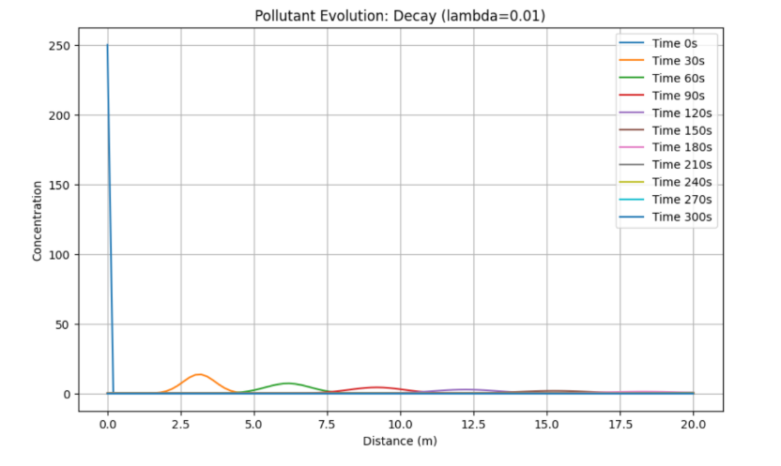
\
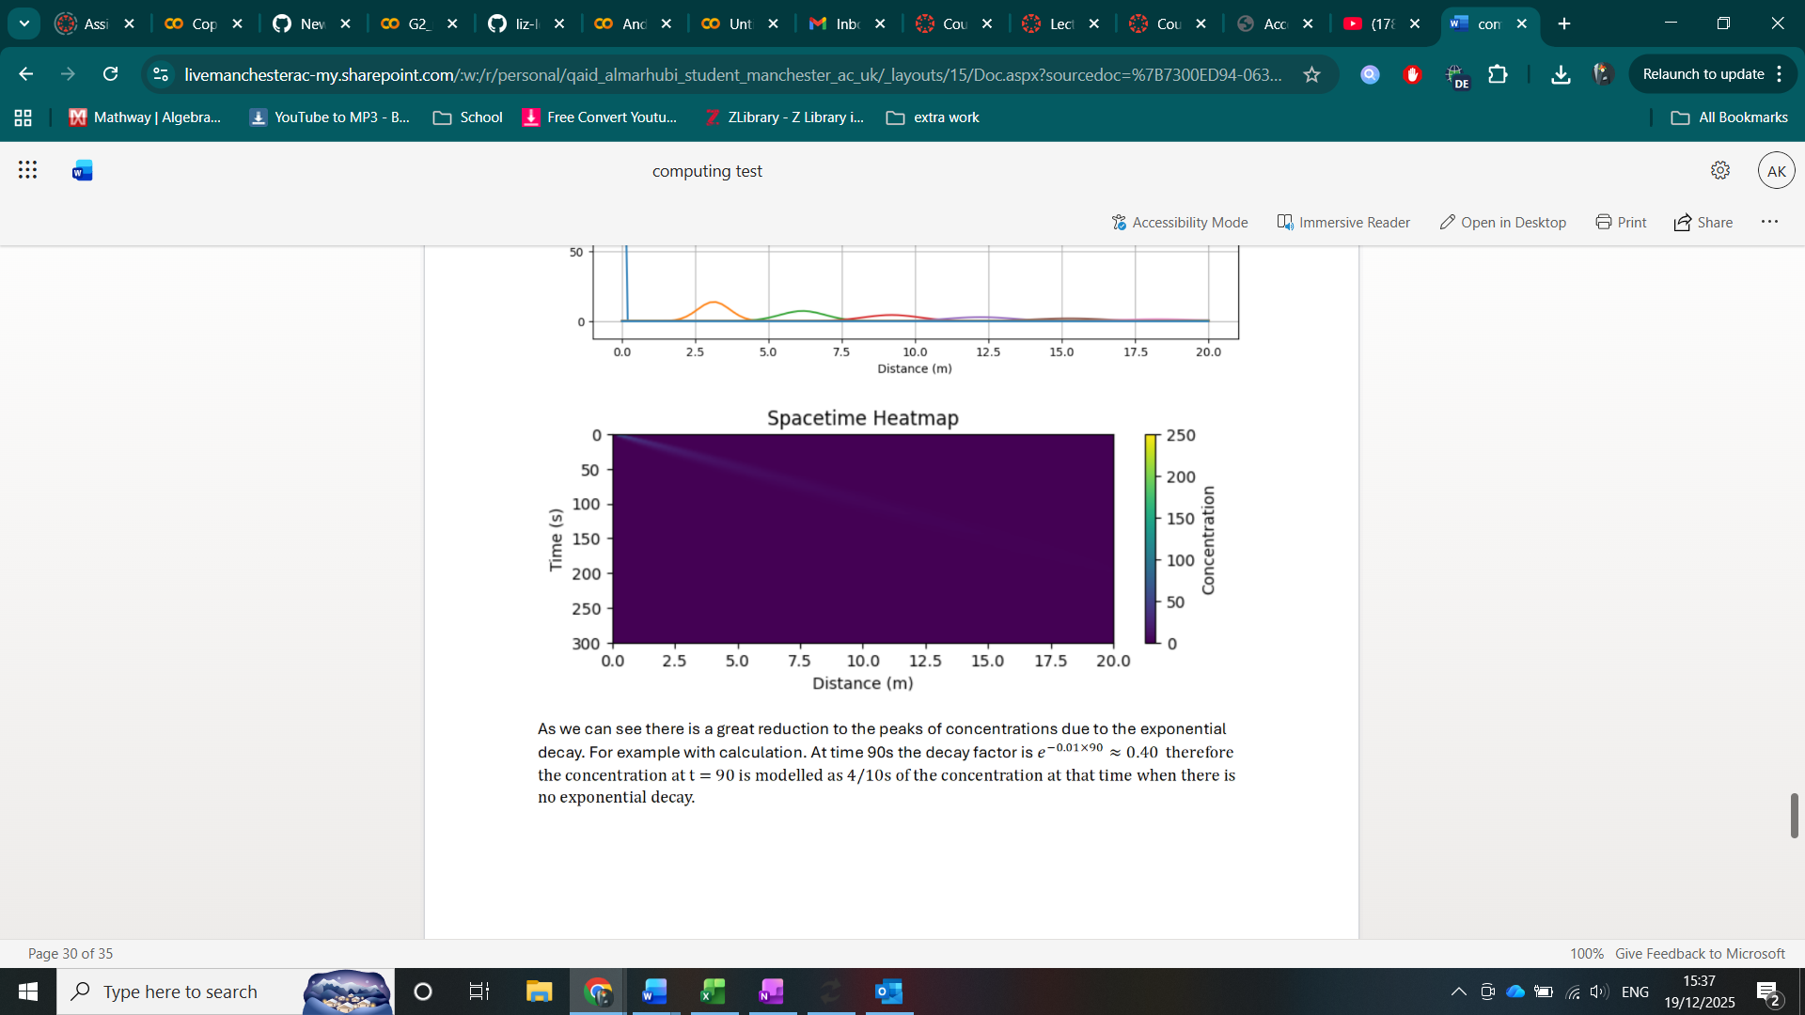
As we can see there is a great reduction to the peaks of concentrations due to the exponential decay. For example with calculation. At time 90s the decay factor is 𝑒−0.01×90≈0.40 therefore the concentration at t = 90 is modelled as 4/10s of the concentration at that time when there is no exponential decay.

